Chapter 8, Problem 5.

Refer to the circuit in Fig. 8.66. Determine:

(a) i(0⁺) and v(0⁺),

(b) di(0⁺)/dt and dv(0⁺)/dt,

(c) i(∞) and v(∞).

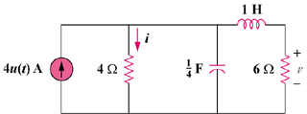

Figure 8.66
For Prob. 8.5.

